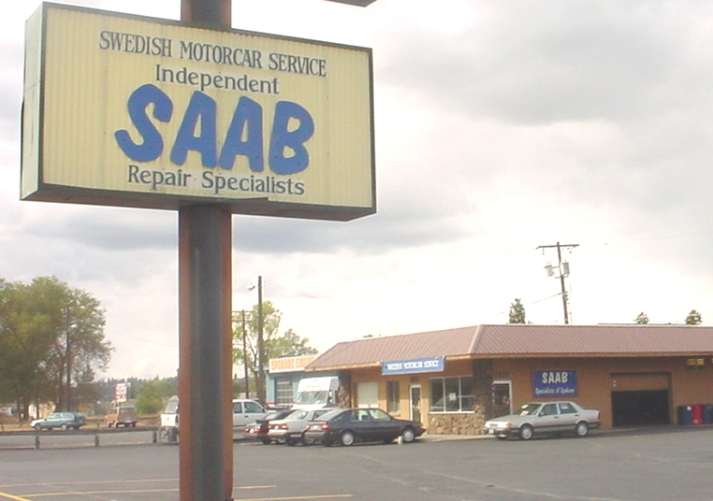
Welcome to Swedish Motorcar Service!
Independent Saab Repair Specialists
1211 E. Francis, Spokane, WA 99208 – (509) 487-3308

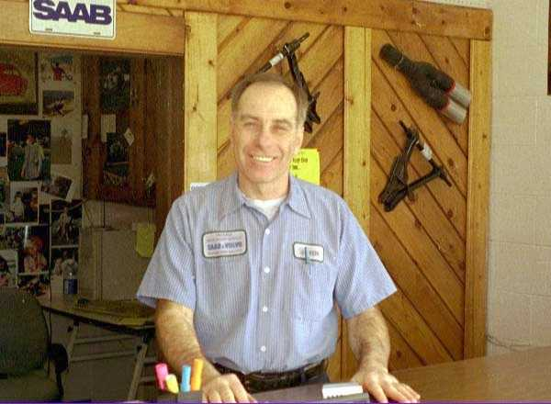
Greetings Saab Friends!

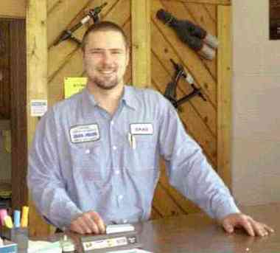
I have enjoyed servicing Saab automobiles since 1967, and have been an Independent Saab Repair Specialist since 1972. In 1991, my sons, Dan and Mike and I opened Swedish Motorcar Service in Spokane. They have since become Mechanical Engineers. We were fortunate to find Brad Hone, who has been with us since 1998.

Brad is one of the finest Saab techs I have known, and shares our family ethic for honesty, competence, hard work and meeting the challenges of complete car care for our Saab friends. We are much closer to a ‘Saab Hospital’ than a business which simply sells its parts and service. Brad and I share that conviction, and we make a great team.

The niche we fill: long-term comprehensive service for your Saab...

The dealership, working with the Saab service network is best for new car sales-support, and to provide warranty repairs, factory upgrades and recalls. No one else can provide these services effectively. But “factory specified” maintenance, by itself, is not sufficient even as early as the first 30,000 major servicing. Saab’s service requirements are designed to competitively sell cars as “low maintenance” so what they publish is the bare minimum servicing necessary to satisfy comparison shoppers and lessees who are the mainstay of the auto industry. Over half of all car sales are leased or traded-in before 33 months. Warranty or Lease requirements are the only concern for short-term owners.

Like all automakers, competitive marketing strategies dictate what Saab, and all other manufacturers publish for maintenance specifications; not the long term needs of the vehicle.

As for “after-market” maintenance, the chain stores and generic service shops may or may not even follow the minimal factory lists, but even worse, there is no one familiar with Saab to perform them. Thus the word “service” usually means an “oil change” and “major service...” a “tune-up”. This then translates to the replacement of whatever parts the shop deems to sell to the customer. Past service records are not tracked, so items are missed or can be unnecessarily duplicated. Chain stores will often advertise “30-60-90,000” Major Service Specials to sell the fast-moving parts, filters & lubricants listed, and look for opportunities to sell high-profit, quick replacements such as brakes, shocks & mufflers.

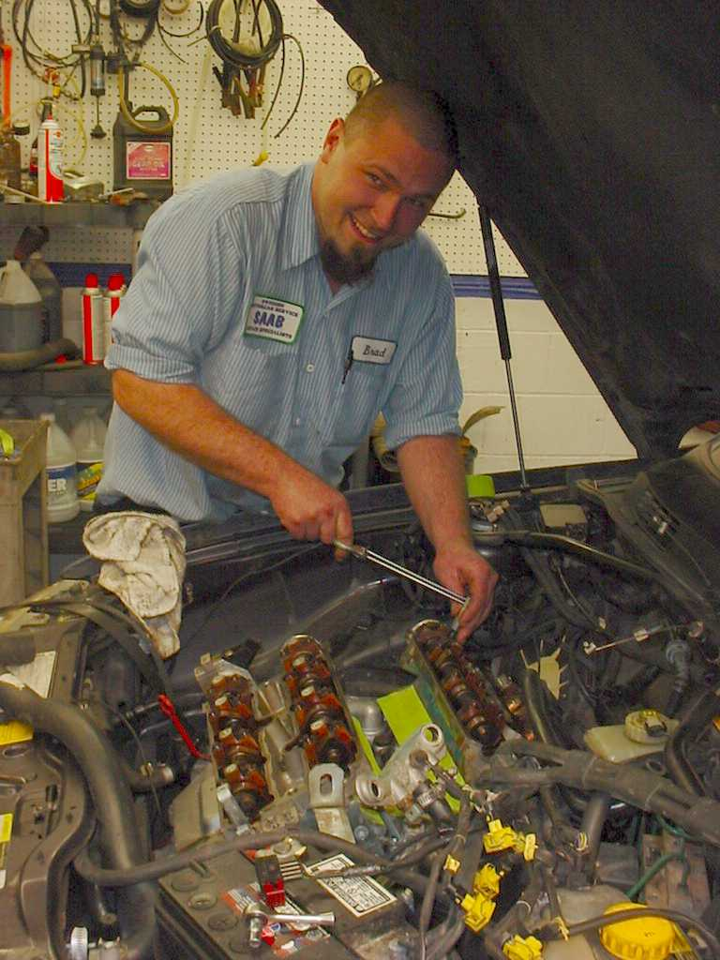
Both ‘factory’ & ‘after-market’ maintenance are akin to buying fast food from a burger chain, and do not address all of your actual maintenance needs. Long-term car care cannot be managed this way, any more than an emergency room can manage your health care. Unfortunately, the entire auto industry is geared for competing for the short-term owner’s business with pre-packaged service, simple & profitable, regardless of the longer term owner’s intentions or needs.

As “Independent Specialists” we have a different approach than a dealership or conventional repair shop. In addition to “by the book” service, we provide Long-term, Preventive Maintenance for all Saab models, new and old. Servicing Saabs preventively satisfies & exceeds warranty requirements. Our goals are to maintain your Saab in such a way that it will remain reliable and affordable throughout an extended service life of many years. We do this by following a more realistic service plan than the one published by Saab. We use superior lubricants, and change them at proper intervals, before mechanical damage is incurred. We do everything possible to prevent failures on the road through better inspections, replacing some parts before they fail, and by developing counter-measures to address known weaknesses in individual models. Timely service procedures of major components such as engines and transmissions will in most cases avoid major replacement costs. In my opinion, this is smart vehicle management, and overall will keep operating expenses / per mile lower, with higher reliability than any other strategy.


Owners interested in keeping their Saab long-term can start right from new, with 5000-7500 mile oil changes.

Even lease- and short term owners with Prepaid Maintenance are wise to change oil more frequently. They often decide to keep their cars, and should consider protecting their possible future investment. Most of our customers keep their Saabs beyond 200,000, sometimes 300,000 miles, and we think that our good service was a big part of that decision.☺

At 30,000 miles, the first Major Service should be supplemented because Saab’s checklist has shortcomings: Some important Inspections, Suspension Lubrications & Transmission fluid / Gear Oil changes are omitted in the service book.

Between 45,000-60,000 miles, there are many crucial supplements. A full third of essential service is not published. Serpentine Pulley(s) should be scrutinized and replaced if questionable. Thermostats, Coolant, Brake & Clutch Fluid, Power Steering & Transmission fluids & Gear Oils should be changed. Higher viscosity motor oil should be employed.

Because of our ongoing observations, we continually update our service plan. Through this experience, we continually improve our inspections & service procedures to prevent problems and increase the service life of your Saab. In this way, our maintenance is much the same as a medical practice. “By-the-Book” service is a starting point only; it does not adapt with ongoing experience or problematic trends.


Ours is not the ordinary “Oil Change”. At each 5000-7500 miles, (7500 on 9-3 Sport Sedans) we go through a comprehensive checklist far more detailed than Saab’s routine maintenance checklist.

Included is a review of your records and past notes to determine if any other service items, inspections or repairs are coming due, which we had notated to look for at this time. Beside the inspections and adjustments, we give a comprehensive Road Test along with many performance tests to the engine, transmission, steering and brake systems, AC, engine cooling and others. We then record our observations and make recommendations for next time. This is the core of our Preventive Maintenance.

Our full 5000 mile Oil & Inspections Service (1 hr.) uses Mobil1 Synthetic Oil, (Mann filter). We mix viscosities for your Saab’s age & the season. It costs approx. $112 plus tax, and is more inclusive than Saab’s 15,000 mile annual service.

Some owners of lower mileage Saabs choose our Half-hour Minor Synthetic Service, alternating with the full service every other time. It usually costs $75 + tax, if no other adjustments, fluids or parts are needed.

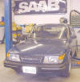
You will never be asked to buy any replacement part or repair unless in our opinion you truly need it. While many “oil change” services have become “search and sell” missions for filters, fluids, brakes and other items that you may not yet need, ours is a genuine evaluation of your Saab, as a part of a comprehensive, long-term maintenance plan customized for you. Brad and I do everything possible to match your service needs with the age of your Saab, your driving requirements (in-town commuting, or the primary family traveling car,) your driving habits and budget.

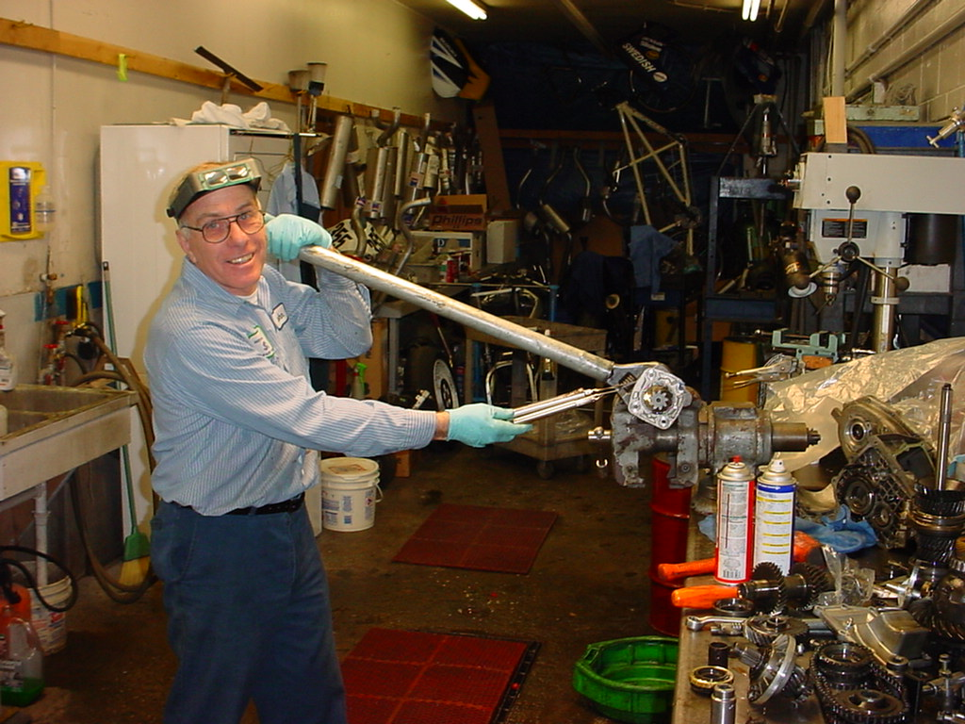
We are completely dedicated to the highest quality maintenance and repair, and to help our customers educate themselves, so that they can optimize their service dollars and protect their investment. We consider our professionalism to be a model for the industry, and believe that the definition of a professional is one who holds the benefit of one’s clients above all else, especially sales or profit considerations.

We offer nearly all repairs and service for the life of your Saab. Most of our customers keep their Saabs 10-15-20 years, which in today’s market, is the only effective way of avoiding the steep depreciation rates of any new automobile. Look at any Leasing Plan, and what you are essentially seeing is the depreciation of that vehicle over the first two or three years, with interest added, broken into monthly payments.

Preventive maintenance is also the most cost-effective means of assuring the reliability of your vehicle, and protecting your long term investment.

Some new owners are not accustomed to Preventive Maintenance as a means for keeping their Saab long-term, hedging against depreciation. They accept breakdowns as inevitable for an older car, and are resigned to trading by 100,000 miles if not earlier, for reliability’s sake. Our experience does not bear this out! Much of the repair work we see could have been prevented with good prior maintenance, and most of the expensive, major component failures could have been prevented with the maintenance additions we provide,

hence our reasons for adding these service items to our program.


Our service plans and methods change constantly with what we see are the problematic areas developing for each model at specific mileages. The failures we see with serpentine belt systems is a good example, and we have responded with more frequent inspections, either by removal, or with a strobe light & stethoscope. There are literally scores of other examples, such as Suspension Joint Lubrications, Thermostat replacements, additional Transmission services, Preventive Fuel Pump replacements, Modified Fluid and Filter change intervals and customized Oil viscosities for the particular engine, its age, and the time of year.

As a long-term plan, Preventive Maintenance will usually double the Saab’s service life, for an overall minimum cost. Driving a vehicle past 100,000 miles, or purchasing a good used Saab which has been properly maintained, is the only means to make up for depreciation losses incurred while the Saab was new. In either case, effective Preventive Maintenance has to go along with the plan. Those who lease their new Saab should also consider protecting their future investment should they buy their vehicle when the lease expires.

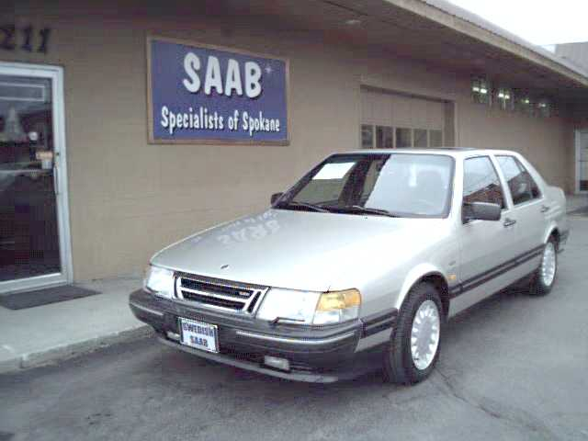
What we need from you... this kind of Car Care is built upon working together. There are always decisions to be made regarding your Saab’s maintenance which will involve our collective judgment – yours and ours.

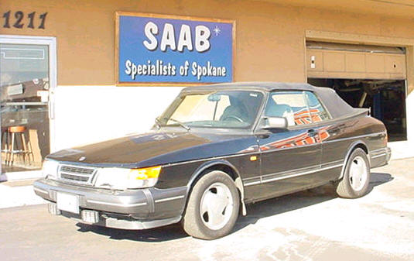
Evaluating your Saab is the best way to begin. We’ll need to review your past service records, perform the inspections included with our 5000 mile Synthetic Oil Service. Then a comprehensive Road Test and mapping out a Service Plan. (The same inspections and evaluations performed every 5000-7500 mile Oil Service intervals are used for a “Buyer’s Inspection” for those purchasing a used Saab, and are essential on a regular basis.) We will then continue to keep detailed records as we work on your Saab over time, and keep them organized with a computer program we wrote specifically for this purpose. We track what has been done, and what is coming due, including any new items which we have learned to be crucial to the maintenance of your model. As it ages, we modify the plan to suit changing needs, such as downgrading the vehicle from a primary family car to an in-town commuter.

Many of our customers have invested wisely into good care of their Saabs, enabling them to pass it on a very safe and reliable old friend to the new teen drivers in the family.

All together, this is how we monitor routine maintenance and critical service items, but avoid unnecessary duplications. We try to help you safely squeeze the most miles out of every component, such as brake pads & rotors, axle boots, belts and exhaust, while at the same time preserve reliability by replacing some components before they fail, such as a fuel pump, engine thermostat or serpentine pulley. It allows you to enjoy the safety and quality of a well maintained Saab for the least annual costs, and preserve that Saab for many years. You will not find this kind of service at any dealership, generic repair shop or quick lube. Perhaps the most important facet of our Preventive Maintenance program is that with our help, you will be educated, informed, and in charge of the decisions affecting your Saab.

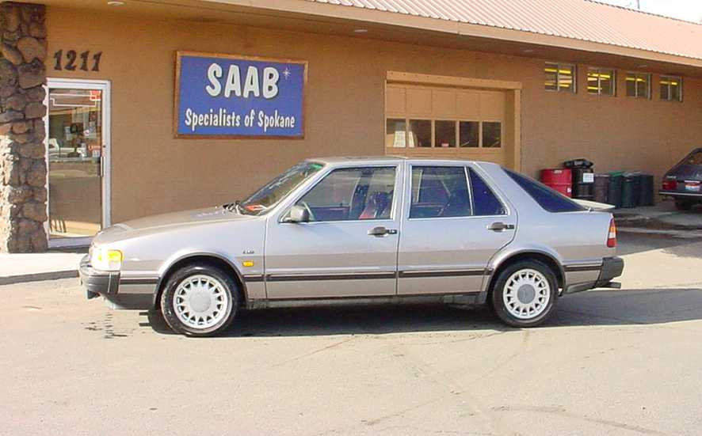
As devotees of Saab repair & maintenance, we know that this is the only way to cost-effectively maintain your Saab’s safety, reliability and longevity. We invite you to allow us to service your newer Saab while it is still under warranty, or to supplement that service if you choose to have our local dealer, Jaremko Saab, do the work.

We are happy to serve you either way. Your warranty will remain intact, and after it has expired, your Saab will be in far better condition to continue on its 200,000 mile journey still ahead!

We have shared this flyer and all other SAAB Flyers like it on our website www.saabspokane.com and have published other articles on a national basis through the Saab Club of America magazine, NINES.


Thanks for Reading! ☺

John Lippis & Brad Hone, Frank Denn
