If you use Regular Fuel – Take it Easy! Detonation can COST AN ENGINE !
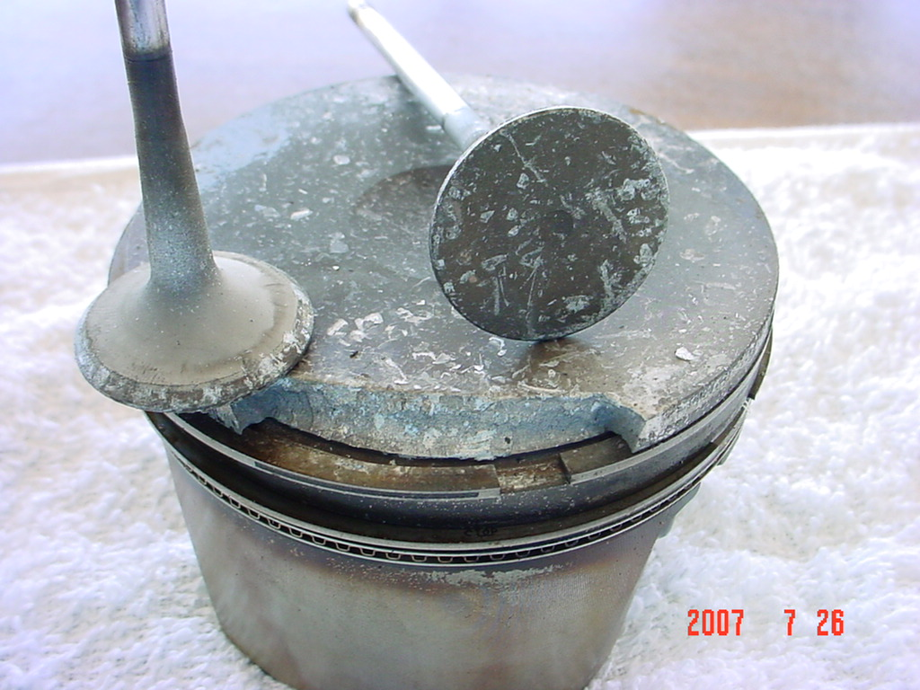

Most 4 Cylinder Saabs will run on 87 octane fuel, but they run better with name brand Higher Octanes. Some V6’s require 92.
87 Octane is usually Ok for In-town driving in cooler weather
For HOT SUMMER Highway Speeds, using the AC, or in MOUNTAINS Use 89 OR 92.
With Most Engines “MIDDLE GRADE” (89) is a safe Choice.
“H.O.T” (HIGH OUTPUT ENGINES) should use 92 OCTANE if driven at High Boost Pressures – High Speeds & Hot Temps.
We also Recommend adding Marvel Mystery Oil to your Fuel to reduce detonation, Lubricate Valves and Prevent Fuel Pump Seizure.
To be sure, CONSULT YOUR OWNER’S MANUAL!

